Appendix A: AATF Request for Proposal
Aero Engineering 210S
Affordable Advanced Tactical Fighter
Request for Proposals

- Background

In 1981, USAF began forming requirements for a new air superiority fighter intended to replace the capability of the F-15 Eagle. In June 1981 a request for information (RFI) for the Advanced Tactical Fighter (ATF) was published by the Air Force. Design concepts were provided by defense contractors. The common areas among the concepts were stealth, short takeoff and landing (STOL) and supercruise, that is, supersonic flight without using afterburner. The vision for the ATF was to incorporate emerging technologies including advanced alloys and composite material, advanced fly-by-wire flight control systems, higher-power propulsion systems, and low-observable, or stealth technology.

In September 1983, study contracts were awarded to seven airframe manufacturers for further definition of their designs. By late 1984, ATF requirements had settled on a fighter with a maximum takeoff weight of 50,000 pounds, a mission radius of 800 miles, supercruise speed of Mach 1.4-1.5 and the ability to use a 2,000 ft runway.

A request for proposals (RFP) for the fighter's engine, called the Joint Advanced Fighter Engine (JAFE), was released in May 1983. Pratt & Whitney and General Electric received contracts for development and production of prototype engines in September 1983. This contract sized the engines, long before the airframes were developed.

A request for proposals (RFP) for the fighter was issued in September 1985. In May 1986, the Air Force changed the RFP so that final selection would involve flying prototypes. In July 1986, proposals were provided by Boeing, General Dynamics, Lockheed, Northrop, and McDonnell Douglas. Two contractors, Lockheed and Northrop, were selected in October 1986 to undertake a 50-month demonstration/validation phase, culminating in the flight test of two technology demonstrator prototypes, the YF-22 and the YF-23.

Because of the added weight required for thrust vectoring/reversing nozzles and related systems as tested on the F-15 S/MTD research aircraft, the Air Force changed the takeoff distance requirement to 3,000 feet and removed the thrust reversers on the ATF in late 1987. This change would allow the aircraft to operate from standard NATO 8,000-foot runways for normal operations. In the event of runway damage after an attack, portable arresting gear would allow use of 3,000-foot runways for takeoff and landing. To further limit aircraft size, mission radius was reduced from 800 nautical miles to 375 nautical miles with only 150 nautical miles of that radius flown in supercruise.

Two examples of each prototype were built for the Demonstration-Validation phase: one with General Electric YF120 engines, the other with Pratt & Whitney YF119 engines. The first YF-23 made its maiden flight on 27 August 1990 and the first YF-22 first flew on 29 September 1990. Flight testing continued until December 1990. Following a review of the flight test results and proposals, the Air Force announced the Lockheed YF-22 with Pratt & Whitney engines as the competition winners on 23 April 1991.

The F-22 has proven to be an amazingly capable fighter, but it has two severe limitations. The first of these is cost. With the incremental cost of building one addition F-22 estimated at $138 million dollars in 2009, F-22 production was halted at only 187. Operating costs are also a severe problem, which makes restarting the F-22 production line unattractive.

The F-22’s second limitation is that it only carries 6 AIM-120 AMRAAM active radar-guided missiles. Their gun and AIM-9 heat-seeking missiles are only useful in close-in dogfights. The best use of stealthy super-cruising fighters avoids close-in dogfights. Modern missiles make dogfighting unnecessary. Designing a fighter that holds more missiles would be most advantageous.

Analysts suggest that the initial sizing of the engines drove the F-22 design to its large, unaffordable size. The oversized engines probably resulted from assuming an F-15-like aerodynamic model to ensure adequate close-in dogfight capability. Figure 1 compares the drag of several fighters at 40,000 ft. Note that the F-106, which has a weapons bay and payload nearly as large as that of the F-22, has less than half the drag of the F-22 at Mach 1.6. Optimizing a fighter aircraft configuration for supersonic flight would yield a much more efficient super-cruiser.
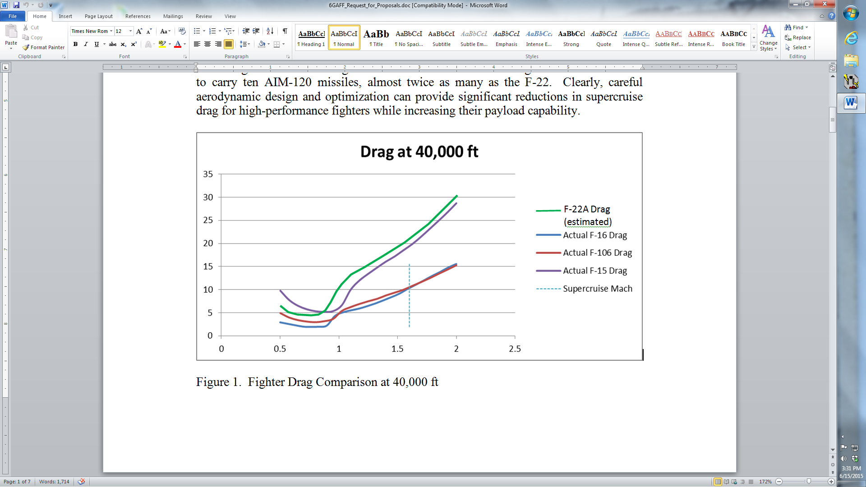
Drag, D (thousands of pounds)

Mach Number, M

Figure 1. Fighter Drag Comparison at 40,000 ft

This design project aims to create a smaller, more cost-effective replacement for the F-22 without super-maneuverability and with an increased missile payload capacity. This design project is aptly named the Affordable Advanced Tactical Fighter (AATF), and it must meet the original ATF mission requirements. The ATF requirements from the year 1987 are listed in Attachments 1 and 2.

The engines available to power the re-imagined fighter were the Pratt and Whitney F119 and the similar General Electric F120, both developed specially for the ATF. However, those engines were sized as part of the ATF development process, so in this study, feel free to resize them. Data for the F119, the engine chosen for the F-22, are tabulated in Attachment 3, but consider it a “rubber engine” which you may size down or up as appropriate.

The key innovation in this design will be an aerodynamic configuration optimized for supercruise, stealth, and excellent high-speed maneuverability while carrying large air-to-air payloads. The plane must be sized to carry at least eight AIM-120 air-to-air missiles and have a combat mission radius of at least 375 nautical miles with 150 nautical miles of that being flown at Mach 1.5 without afterburner.

Requirements

Design a fighter aircraft to meet the requirements of the AATF mission.

Attachment 1 provides the specific information on the primary offensive counter-air (OCA) mission.

Attachment 2 provides the specific minimum performance requirements.

Design a fighter aircraft to meet the Capabilities and Characteristics listed in Section 3 below.-

Demonstrate meeting Statement of Objectives 2.1 and 2.2 above using the Measures of Merit in Section 4 below.

- Other Required Capabilities and Characteristics
  - Single Pilot Operation (required): Aircraft will be designed to be flown by a single pilot in a comfortable cockpit with excellent all-around visibility. All systems and weapons will be designed for single-pilot operation and employment.
  - Maintenance/Servicing (required): The design must allow easy access to and removal of primary elements of all major systems. Minimize requirements for unique support equipment—development of any new support equipment will be included in program cost estimates.
  - Structure (required): Design limit load factors are +9 and -3 vertical g’s in the clean configuration at maximum gross weight. The structure should withstand a dynamic pressure of 2166 psf (Mach 1.2 at sea level). A factor of safety of 1.5 shall be used to calculate all design ultimate loads. Primary structures should be designed for durability and damage tolerance. Design service life is 8,000 hours.
  - Fuel/Fuel Tanks (required): Primary design fuel is standard JP-8 or Jet-A (6.8 lb/gal = 50.87 lb/ft³) jet engine fuel. If external fuel tanks are required (this is not desirable) they must be retained for the entire mission.
  - Stability (required): Un-augmented subsonic longitudinal static margin (S.M.) shall be no greater than 10% and no less than -10%. Maximum c.g. excursion for all loading conditions must not exceed 7% M.A.C. An automated stability augmentation system is mandatory if the design has any undesirable un-augmented stability characteristics.
  - As the AATF will likely be required to operate from austere forward operating bases, short field takeoff and landing capability and maximum climb angle for obstacle clearance during departure are highly desired characteristics.
  - Cost requirements are broken into per unit production costs (recurring) and non-recurring (NRE) expenses. For direct comparison to the F-22 acquisition, the per unit production costs are defined as the incremental cost of producing the 187th aircraft and will include the entire aircraft. Due to learning curve and some production tooling costs, this cost will be affected the number of aircraft bought. NRE will consist of all development and production preparation costs. When able, report both Development and Production NRE costs. Since AATF costs are expected to be lower than the F-22, be prepared to report flyaway costs for an 800 aircraft buy. Plan on building 10 flight test aircraft, in both the 187 and 800 aircraft buy.
    - Total NRE costs will not exceed $10B for 800/$12B for 187 aircraft in constant 2022 dollars
    - Per unit cost will not exceed $60MM for 800/$80MM for 187 aircraft in constant 2022 dollars
    - All practical measures will be taken to minimize total life cycle costs.
    - Report and compare the costs for a 187 and 800 aircraft purchase.

- Measures of Merit—Designs will be evaluated against design mission performance, other performance requirements, cost, and the Measures of Merit described below.
  - Aircraft geometry and systems integration (wing and control surface area, fuselage length, width/diameter, size and volume, frontal cross sectional area distribution, wetted area, inlet and diffuser dimensions, landing gear geometry, sensor and avionics locations, crew station, etc.)
  - Weight and center of gravity summary, gross takeoff weight, empty weight, mission fuel weight, wing loading (W_{TO} /S), thrust-to-weight ratio (T_{SL}/W_{TO}), mission fuel fraction (W_{f}/W_{TO}) including external tanks, if used, and weight breakdown by component must be reported.
  - Dimensioned drawings of the aircraft with data blocks. These are computer-drawn three-view and perspective drawings or views from a CAD model or photographs of a physical model. Show visual and data comparisons with other relevant aircraft.
  - Mission duration, radius or range, total fuel burn, and fuel burn by mission segment for design mission.
  - Takeoff and landing distance at max gross weight at sea level standard day. Maximum Climb Angle using military thrust at sea level will also be considered.
  - Performance for AATF design mission loadings.
    - L/D_{max} at Sea Level, 80% W_{man}
    - Maximum Endurance at 30,000 ft, 80% W_{man}
    - Maximum Range at 30,000 ft, 80% W_{man}
    - Maximum Climb Angle at Sea Level, Max Gross Takeoff Weight (W_{TO})
    - 1-g Maximum Thrust Specific Excess Power Envelope at 50% W_{man}
    - Energy Maneuverability at 10,000 ft MSL and 30,000 ft MSL at 50% W_{man}
    - NRE, per unit production cost, per unit flyaway cost, operations costs and total life cycle costs. Show cost trades for aircraft buys of 187 to 800 units.
  - Develop and present the alternative concepts considered leading to the down-select of your preferred concept. The methods and decision matrix rationale used for the down-select shall be presented in an Analysis of Alternatives briefing.
  - Provide a slides-only Final Design Analysis of your individual design that meets the requirements of this RFP.

- Attachments

Attachment 1 provides specific information on the primary offensive counter-air (OCA) mission

Attachment 2 provides the specific minimum performance requirements.

Attachment 3 lists characteristics of the F119 engine. Feel free to scale this engine up or down by scaling both mil and max thrust by the same factor. Do this by manipulating Jet10 cell C29 but not D29.

Attachment 4 lists characteristics of the weapons which could be carried. Note that 8x AIM-120 missiles and 2x AIM-9 missiles are required to meet the objective (20mm gun is not required).

Attachment 1 (GE1 inputs)
AATF Offensive Counter-Air Mission

Table 1. Eight (8) AIM-120 AMRAAM Offensive Counter Air (OCA) Mission

Leg Description
1 STTO: Preflight and Takeoff Fuel allowance for sea level takeoff
- Start (200 lb/engine),
- Warm-up/taxi (30 lb/min/engine – plan on 30 minutes ground time),
- Mil power run up (500 lb/engine)
- Fuel to accelerate on the ground to takeoff speed, rotate, and lift off
- Fuel to accelerate to climb speed at take-off thrust (no distance credit allowed)

2 Accel: Accelerate from sea level takeoff toward best climb conditions (you choose conditions)

3 Climb: Climb and accelerate to 0.9M and 35,000 ft or higher

4 Cruise: Cruise out at least 225 NM total at 0.9M ending at 35,000 ft or higher. (225NM min range is comparing to the sum of Accel, Climb, Cruise, and Supercruise distances, Not usually an input.)

5 Supercruise: Accelerate to at least 1.5M (specified in Constraints) and Supercruise at least 150 NM at 35,000 ft or higher (Also in Constraints)

6 Combat: Supersonic Air Combat: Fuel required to perform two maximum performance, 4-g, 360-degree turns at 30,000 ft or above and at least 1.2M. Weapons Delivery: Fire all missiles (Drop payload/booster is all expendable payload weight)

7 Supercruise: Egress and Supercruise back: Accelerate and climb from combat conditions to at least 1.5M (specified in Constraints) at or above 35,000 ft (Also in Constraints) and Supercruise back at least 150 NM at 35,000 ft or higher

8 Cruise: Subsonic cruise back at least 225 nm at 0.9M at or above 35,000 ft. (225NM min range is comparing to the sum of Supercruise (back), Climb, and Cruise, Not usually an input.)

9 Loiter: Descend to 10,000 feet (No distance credit allowed) plus reserve fuel for 20 minutes. (you choose Mach for this endurance task)

Note: Jet11 is calculating performance parameters on standard day conditions with no wind.

Attachment 2 (GE2 inputs)
RFP Compliance Table

Table 2. AATF Threshold and Objective Performance Requirements

Criteria | Threshold | Objective
Mission Radius | 375 nautical miles | 410 nautical miles
Weapons Payload | 8x AIM-120 | 8x AIM-120  + 2x AIM-9
Takeoff Distance | 3,000 ft | 2,500 ft
Landing Distance | 5,000 ft | 3,500 ft
Max Mach Number at W_{man} and Optimum Altitudeª | M2.0 | M2.2
Supercruise Mach Number at W_{man} and Optimum Altitudeª | M1.5 | M1.8
Specific Excess Power in Max Thrust at 30,000 ft MSL and W_{man} ^{a,b} | 400 ft/s at M1.15 | 500 ft/s at M1.15
Specific Excess Power in Mil Thrust at 10,000 ft MSL and W_{man} ^{a,b} | 400 ft/s at 0.9M | 500 ft/s at 0.9M
Combat Turn  at 30,000 ft MSL and W_{man} ^{a,b} | 3 g at M1.2 | 4 g at M1.2
Combat Turn  at 10,000 ft MSL and W_{man} ^{a,b} | 4 g at 0.9M | 4.5 g at 0.9M
Recurring Cost per unit  for 187 aircraft FY2022$ | $115M | $100M
Recurring Cost per unit  for 800 aircraft FY2022$ | $75M | $63M
^{a.} Maneuver weight (W_{man}) is the aircraft weight with 50% fuel, eight AIM-120 AMRAAM missiles.
^{b.} MSL signifies altitude above mean sea level

Attachment 3
Candidate Engine Characteristics

Table 3. Pratt and Whitney F119-PW-100 Afterburning Turbofan

Max Thrust in Afterburner: 35,500 lb TSFC: 2.0/hr
Mil Thrust no Afterburner: 25,100 lb TSFC: 0.92/hr
Normal Thrust Continuous: 24,300 lb TSFC: 0.88/hr
Length: 203 inches and Diameter: 42 inches
Weight Installed: 5,080 lb
Cost (FY1995 $): $3,300,000

Note: Consider this a rubber engine. When sizing up or down, keep the ratio of maximum thrust to military thrust the same. In other words, when resizing, multiply both mil and max thrust by the same scaling factor. The Jet-10 analysis software will automatically rescale engine dimensions and weight.

Attachment 4
Weapons

Table 4. Weapons Parameters

AIM – 9X Sidewinder Heat-Seeking Missile
Launch weight: | 187 lb
Length: | 118 in
Max span: | 17.5 in
Body diameter: | 5 in
Launcher rail weight: | 50 lb
Launcher rail length: | 9.2 ft
AIM – 120D AMRAAM Active Radar-Guided Missile
Launch weight: | 335 lb
Length: | 144 in
Max span: | 16 in
Body diameter: | 7 in
Launcher rail weight: | 80 lb
Launcher rail length: | 11.1 ft
M61A2 20 mm Cannon
Cannon weight: | 275 lb
Length: | 74 in
Max diameter: | 10 in
Ammunition feed system (500 rounds) weight: 300 lb
Ammunition drum length: | 25 in
Diameter: | 25 in
Ammunition (20 mm): | 0.58 each
Returned Casings: | 0.26 each

